# Bijel Procedure

**Deconvolution**

Blind deconvolution is used to remove out of focus light.

Settings:

* Iterations: 10
* Method: blind
* PSF: use values from LAS X
* Mode: confocal

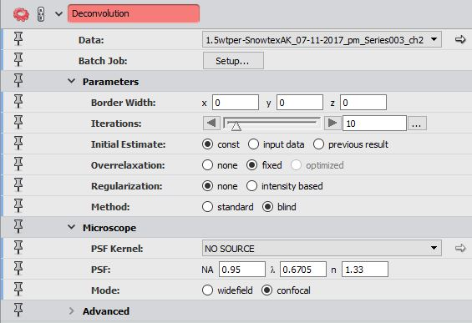

**Median Filter**

The median filter averages small sections of pixels in grayscale images. This reduces contrast and softens the edges of objects in the images.

Settings:

* Interpretation: 3D
* Iterations: 5

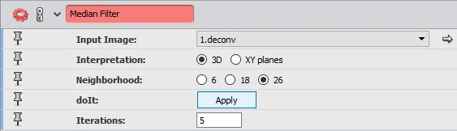

**Normalize Grayscale**

This module changes the range of pixel intensities to increase contrast, which makes binarization easier. It is applied to each XY-slice to maintain brightness throughout the z-stack.

Settings:

* Interpretation: XY planes
* Range Mode: percentile

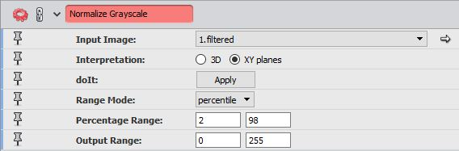

**Interactive Thresholding**

Thresholding transforms a grayscale image to a binary image. This module allows the user to interactively change the threshold and has a preview of the binarized image overlaid on the grayscale image.

**Resample**

Resampling allows the user to enlarge or shrink the sample while recalculating the data.

Settings:

* Average: 3 3 1

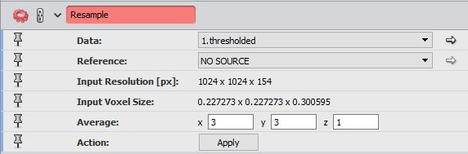

**Average Object Thickness**

**This module computes the average thickness of objects in 3D, which is displayed in a table. The module uses either a parallel plate, cylinder rod, or sphere model.**

**Settings:**

* **Model: Cylinder Rod Model**

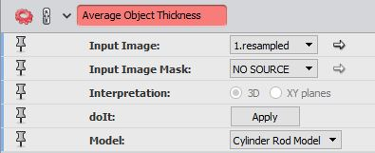

**Generate Surface**

This module computes a triangular approximation of the interface between different regions. This can be used to visualize a 3D model of the image stacks. To view the surface, apply a surface view module and a bounding box to border data.

Settings:

* For bijel:
  + Border: on
  + Settings: Adjust Coordinates - off
  + Smoothing: constrained smoothing
  + Surface View:
    - Drawstyle: transparent
    - Colors: constant
    - Base Trans: 0.5
    - Colormap: red
* For interface:
  + Border: off
  + Smoothing: constrained smoothing

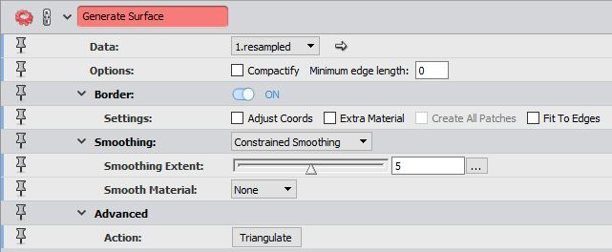

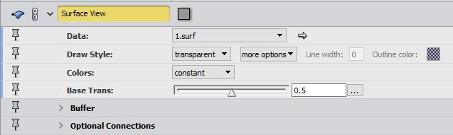

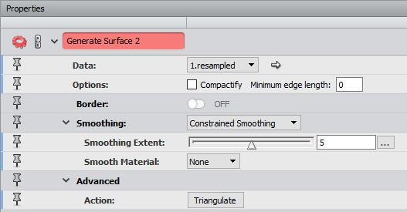

**Surface Area Volume**

This module is attached to a surface and calculates the area and volume of each material. Both the area and volume are signed, however the total area given accounts for both sides of the materials (interior and exterior).

**Volume Fraction**

This module computes the fraction of the total bounding box volume for each material.

Settings:

* Interpretation: 3D

**Bounding Box Volume**

This module returns the total volume of the bounding box in a stack of images.

**Isosurface**

This module creates and isosurface from a grayscale image. This module also has the option to downsample.

Settings:

* Threshold: (…) 🡪 configure 🡪 set min to 0 and max to 255
* Threshold: lower value from interactive threshold
* Draw Style: more options 🡪 create surface
* Down Sample: on
* Average: 6 6 6

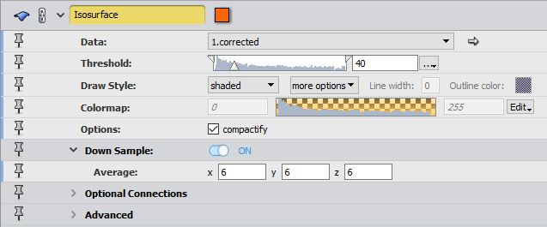

**Extract Surface**

This module allows you to extract the surface displayed by the isosurface module.

**Remesh Surface**

This module remeshes the surface to optimize the triangular mesh in a surface.

Settings:

* Desired Size: %100

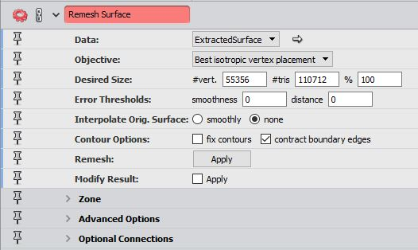

**Curvature**

This module computes the curvature for a triangular mesh surface. This data can be visualized using the histogram module or a surface view module.

Settings:

* Method: on vertices
* Output: Mean curvature/Gaussian curvature
* Histogram:
  + Max Num Bins: 1024
  + Plot Options: line drawing - off
  + Plot Options: logarithmic – on
* Surface View:
  + Colormap: edit🡪physics.icol 🡪 adjust range to get spectrum

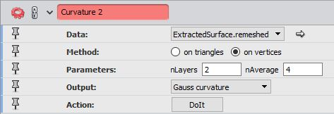

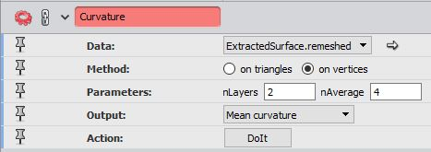

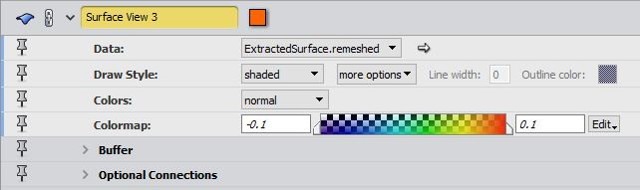

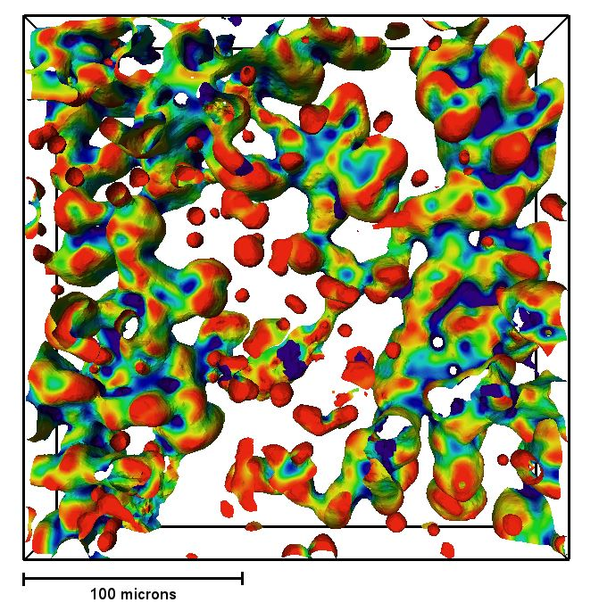

**Scalebar**

**Displays a scalebar in the viewer window. Settings change the axis, position and size. Turn on custom size to automatically scale to nice, whole numbers.**

**Settings:**

* **Frame: x-Axis**
* **Unit: microns (usually)**
* **Color: black**
* **Line Width: 3**
* **Font: Arial black 18pt. black color**

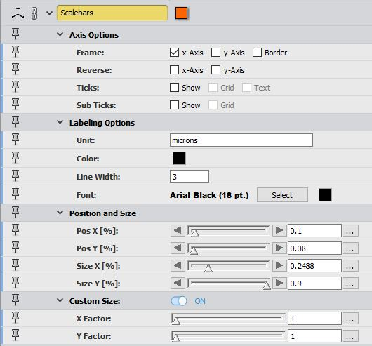

**Dynamic Samples**

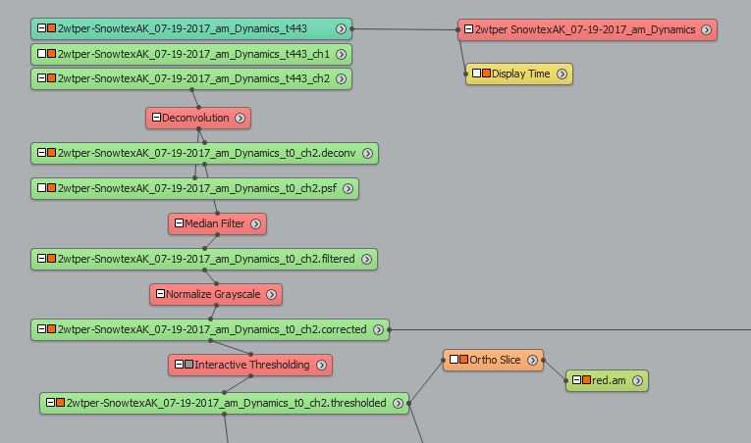

**For dynamic samples (xyzt), apply deconvolution, median filter, normalize grayscale, and interactive thresholding to the first time step as before. Attach an ortho slice with the red.am colormap set between 0 and 0.**

**Settings:**

* **Frame: black**

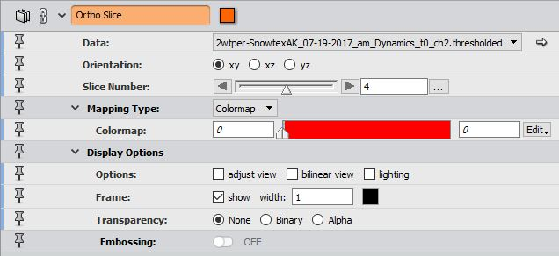

**Attach a display time module to the series control.**

**Settings:**

* **Position/size: adjust to center**
* **Type: horizontal**
* **Style: frame, solid, progress bar & custom text – on**
* **Style: value text – off**
* **Colors: text – black, foreground – red, background – black, frame – white**
* **Custom text: 0/”0 sec” #timeSteps/”totalTime sec”**
* **Font: arial black (18 pt.)**

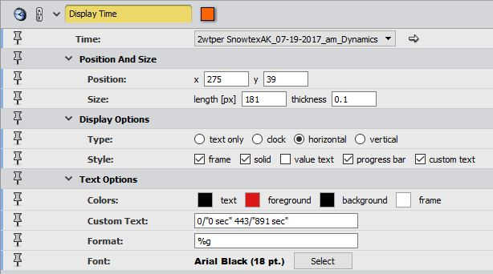

**To apply to every time step, update the text file “BijelsDynamic.txt” and copy/paste into the tcl command window. This will save a snapshot of an ortho slice for each time step to be used to make a video in ImageJ.**